**Moving Average (MA)**

In the moving average section, we tried to take an average of the data within a time window. We did trial and error to split the time window to 4, 6, 12, and 18 weeks to select the best time window aka order, for the moving average. In the graph illustrated below, we can see that Moving Average 6 (MA6) has a better fit on the *WeeklySales* training set compared the rest of the three graphs. As result, we would go with MA6 for deeper analysis. With sufficient time, we also analyzed MA 4, MA12, and MA18 to ensure that our choice of MA is right.

We further investigated MA 6 by applying **Trailing Moving Average**. After applied *rollmean* to the training data and set k=6, the graph is illustrated below:

**Trailing Average Smoother**

In the trailing average smoother section, we used *k=6* and the last moving average for prediction. Since we are using last moving average to fill in all the 38 prediction weeks (nValid), the prediction period on the graphs shows to be a straight line illustrated below. This is a naïve way to predict Walmart’s weekly sales for the next 38 weeks since it only uses the last moving average.

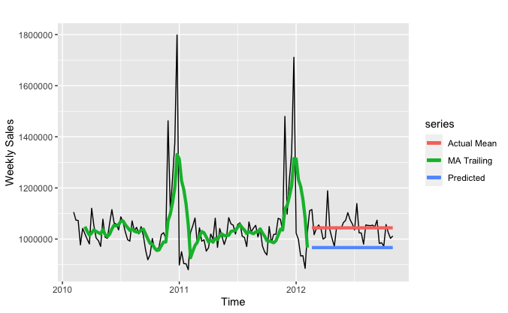

To better make prediction for the following 38 weeks of store sales, we improved the trailing model by employing a for loop to append last moving average of not only the last moving average, but the rolling average for better prediction. We tested different time window: *k = 4, k = 6, k=12, and k=18* to see which time window would have a better fit and accuracy with the testing set.

As graph showed below, we can see that graph *Trailing 4* and *Trailing 6* has better fit for the rolling line and test line; however, when we look at the accuracy score, we can see that trailing moving average with 12 weeks window has the lowest root mean square deviation （RMSE）and mean absolute percentage error (MAPE). As show in the table below, trailing moving average has a RMSE of 50593.8 and MAPE of 3.359, which is the lowest among the four.

|  | **ME** | **RMSE** | **MAE** | **MPE** | **MAPE** | **ACF1** | **Theil’s U** |
| --- | --- | --- | --- | --- | --- | --- | --- |
| **K = 4** | -3996.336 | 57580.03 | 42730.13 | -0.4816351 | 4.154352 | 0.2158959 | 2.842983 |
| **K = 6** | -5056.532 | 57088.12 | 42368.48 | -0.5701634 | 4.105455 | 0.23706 | 3.894264 |
| **K = 12** | 10326.97 | **50593.8** | 35462.27 | 0.9234055 | **3.359151** | 0.2333883 | 4.008283 |
| **K = 18** | 19367.91 | 56019.75 | 43931.72 | 1.754249 | 4.08718 | 0.2797184 | 5.85484 |

Conclusion: the best trailing moving average model is with time window of 12 weeks. It has RMSE of 50593.8 and MAPE of 3.359151.

**Simple Exponential Smoothing (SES)**

Simple Exponential Smoothing is a popular forecasting method. It is similar from moving average, but instead of taking a simple average over a time window, it weights average of all past values, so that the weights decrease exponentially into the past. We are using seasonality as a testing stage to see how the data would react. We are using the artificial neural network (ANN) model to forecast the predicted store sales. We used lag=1 to look for the data for previous week.

With the ANN model accuracy, the RMSE is 60904.42 and MAPE is 191.3546.

Holt’s Linear Trend Model

When we put the data into Holt’s Linear Trend Model (ANN) to forecast 38 weeks of store sale, we can see in the graph that the predicted value is a line. Compared to the actual test set, the predicted line is not so accurate. Since exponential smoothing does not take seasonality into consideration, it is not very accurate. It has a RMSE of 46881.7 and MAPE of 3.284567.

In conclusion for simple exponential smoothing, it is not a very good method to use to forecast or predict future values. Simple exponential smoothing does not take into consideration for trend and seasonality. In our graph, there are obvious seasonality at the end of the year of 2011 and 2012. So simple exponential smoothing is not a good predictor method for the Walmart dataset.

**TBATS Model**

One trivial model we used is TBATS model. TBATS model has the capability to deal with complex seasonality with no seasonality constraints. TBATS is an acronym for key features of the model. **T**: Trigonometric seasonality, **B**: Box-Cox transformation, **A**: ARIMA errors, **T**: Trend, **S**: seasonal components.

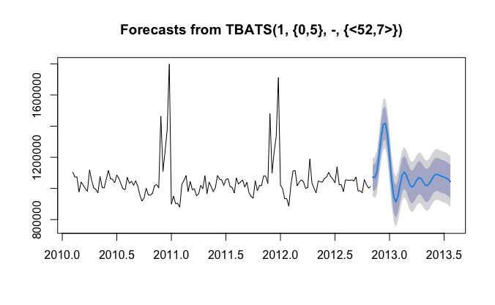

As illustrated in the graph above, the forecast seems very reasonable. TBATS model takes it roots in exponential smoothing methods. In the graph, 1 is the Box-Cox parameter, and {0,5} is the ARMA (0,5) model. <52,7> is the seasonality length and Fourier series.

**Multiple Linear Regression**

In multiple linear regression part, we introduce 7 extra variables. Five of them come from original dataset. Fuel price, Consumer Price Index (CPI) and Unemployment Rate capture the economic factors. Temperature and holiday flag capture demand factors. We also add two variables based on the time plot of sales. We notice that people tend to shop more from the beginning of thanksgiving week to the end of Christmas week, but tend to constraint consumption for several weeks around this period. Therefore, two dummy variables are introduced to capture those two special time periods seperately.

Table: Independent Variables in Multiple Linear Regression

| Variable Name | Meaning |
| --- | --- |
| Fuel.ts | Time series object of fuel price during the experimental period. |
| Cpi.ts | Time series object of Consumer Price Index during the experimental period. |
| Rate.ts | Time series object of Unemployment Rate during the experimental period. |
| Temp.ts | Time series object of temperature during the experimental period. |
| HolidayFlag.ts | Time series object of if national holiday during the experimental period. (Dummy) |
| Xmas.ts | Time series object of if Thanksgiving to Christmas Week during the experimental period. (Dummy) |
| Ny.ts | Time series object of if the weeks around Thanksgiving to Christmas Week during the experimental period. (Dummy) |

Next, we observe the relationship between each feature and sales, and find that: HolidayFlag.ts and Xmas.ts have positive relationship, Ny.ts has negative relationship, and other variables do not have obvious relationship. Then, we use Autocorrelation and Cross-Correlation Function Estimation (CCF) between each variable and sales to find lag relationship. Only Temp.ts and Fuel.ts have lag steps beyond the significance boundary.

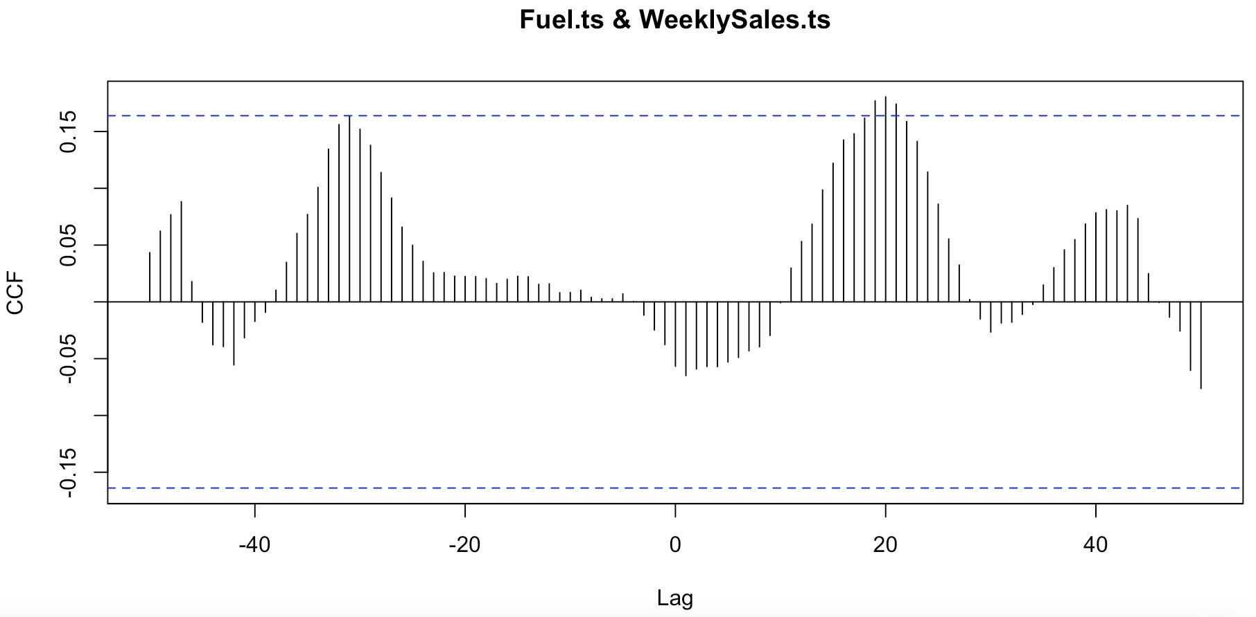

Figure: CCF Plot between Fuel Price and Weekly Sales Data

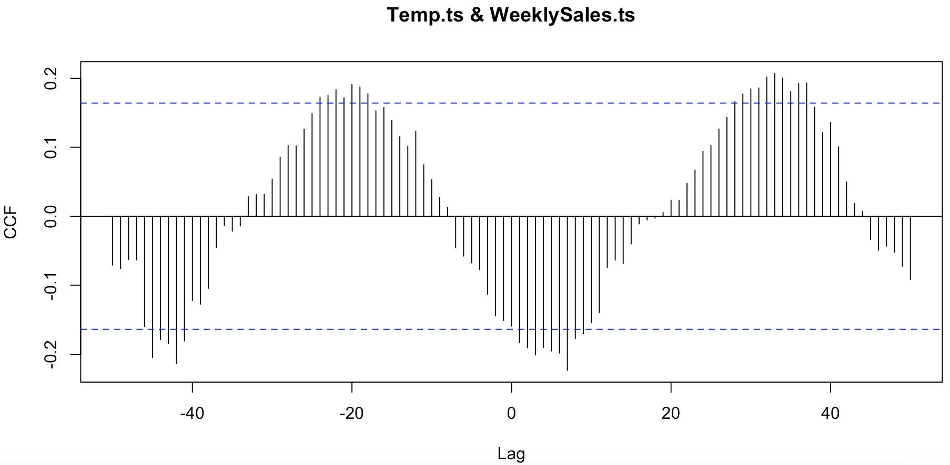

Figure: CCF Plot between Temperature and Weekly Sales Data

According to the CCF plots and simple linear regression function, we choose 20 steps for temperature and 31 steps for fuel price, and build new variables named Lag_Temperatures.ts and Lag_Fuel.ts correspondingly.

Finally, four multiple regression models with different combinations of variables are built to simulate the trend.

Table: Details of Multiple Linear Regressions

| Model | Independent Variables |
| --- | --- |
| m5 | Lag_Temperature.ts, Lag_Fuel.ts, Xmas.ts, Ny.ts |
| m6 | Lag_Temperature.ts, Lag_Fuel.ts, Xmas.ts, Ny.ts, HolidayFlag.ts |
| m7 | Lag_Temperature.ts, Lag_Fuel.ts, Xmas.ts, Ny.ts, HolidayFlag.ts, Cpi.ts |
| m8 | Lag_Temperature.ts, Lag_Fuel.ts, Xmas.ts, Ny.ts, HolidayFlag.ts, Cpi.ts, Rate.ts |

Each model’s performance is shown below.

Table: Performance of Multiple Linear Regressions

| Model | Adj-R2 | P-value | ME | RMSE | MAE | MPE | MAPE |
| --- | --- | --- | --- | --- | --- | --- | --- |
| m5 | 0.5537 | 0 | 0 | 88212.77 | 51726.3 | -0.53882 | 4.74 |
| m6 | 0.5537 | 0 | 0 | 87802.98 | 50790.72 | -0.53187 | 4.66 |
| **m7** | **0.5559** | **0** | **0** | **87167.58** | **51015.43** | **-0.52282** | **4.68** |
| m8 | 0.5518 | 0 | 0 | 87158.40 | 51103.75 | -0.52265 | 4.69 |

Considering the performance of four models, we can find that the model 7 has the highest adjusted R-square, which means that the combination of variables in model 7 can best interpret the variation in sales. At the same time, it has the approximate lowest loss among four models (adding another variable in model 8 will not dramatically reduce the error). Therefore, we choose m7 here. However, when we check the basic assumptions of model 7, we can obviously see the autocorrelation problem at lag 5. Therefore, we also add autocorrelation part into our original model, getting a new model named m7New.

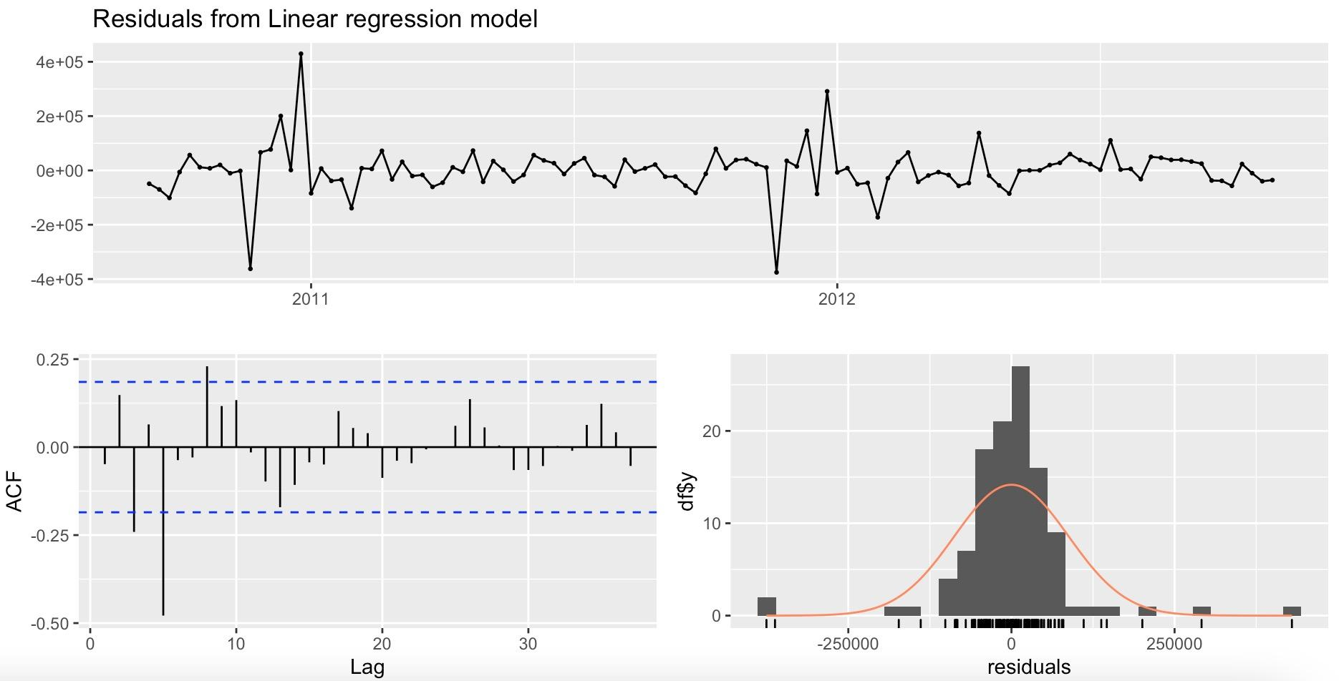

Figure: Check Model 7 Residuals

The Performace of final model will be:

Table: Performance of m7New

| Model | ME | RMSE | MAE | MPE | MAPE |
| --- | --- | --- | --- | --- | --- |
| m7New | -9.720363 | 69803.5 | 46924.75 | -0.056578 | 4.35 |

This model performs far better than the original model so this is our final choice. At last, we also use m7New to fit the original data.

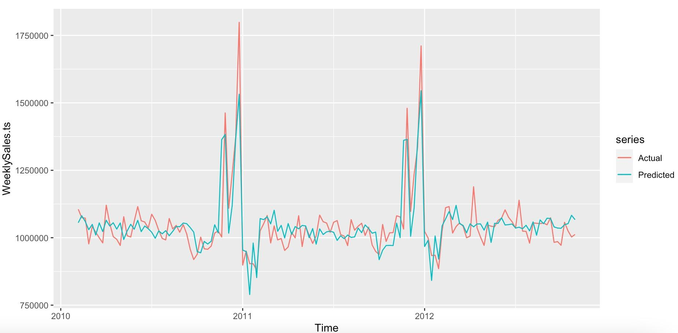

Figure: m7New Fitting Line